COMPLETE END-TO-END JSP–SERVLET CACHE MANAGEMENT PROJECT

COMPLETE PROJECT STRUCTURE
jsp-servlet-cache-app
│
├── pom.xml
│
├── src/main/java
│ └── com/example
│ ├── cache
│ │ └── ReferenceCache.java
│ │
│ ├── listener
│ │ └── CacheStartupListener.java
│ │
│ ├── filter
│ │ └── CacheValidationFilter.java
│ │
│ ├── servlet
│ │ ├── LoginServlet.java
│ │ └── DashboardServlet.java
│ │
│ └── util
│ └── CacheKeys.java
│
├── src/main/webapp
│ ├── login.jsp
│ ├── dashboard.jsp
│ └── WEB-INF
│ └── web.xml

1️⃣ pom.xml (MANDATORY)
<project xmlns="http://maven.apache.org/POM/4.0.0"
xmlns:xsi="http://www.w3.org/2001/XMLSchema-instance"
xsi:schemaLocation="http://maven.apache.org/POM/4.0.0
http://maven.apache.org/xsd/maven-4.0.0.xsd">

<modelVersion>4.0.0</modelVersion>

<groupId>com.example</groupId>
<artifactId>jsp-servlet-cache-app</artifactId>
<version>1.0</version>
<packaging>war</packaging>

<dependencies>

<!-- Servlet API -->
<dependency>
<groupId>javax.servlet</groupId>
<artifactId>javax.servlet-api</artifactId>
<version>4.0.1</version>
<scope>provided</scope>
</dependency>

<!-- JSP -->
<dependency>
<groupId>javax.servlet.jsp</groupId>
<artifactId>javax.servlet.jsp-api</artifactId>
<version>2.3.3</version>
<scope>provided</scope>
</dependency>

<!-- JSTL -->
<dependency>
<groupId>javax.servlet</groupId>
<artifactId>jstl</artifactId>
<version>1.2</version>
</dependency>

</dependencies>

</project>

2️⃣ CACHE KEYS CONSTANT
package com.example.util;

public final class CacheKeys {

private CacheKeys() {}

public static final String REFERENCE_CACHE = "REFERENCE_CACHE";
public static final String CACHE_READY = "CACHE_READY";
}

3️⃣ CACHE LOADER (REFERENCE DATA)
package com.example.cache;

import java.util.*;

public class ReferenceCache {

public static Map<String, String> load() {

Map<String, String> cache = new HashMap<>();

// Simulated DB/API data
cache.put("ADMIN", "Administrator");
cache.put("USER", "Standard User");
cache.put("GUEST", "Guest User");

if (cache.isEmpty()) {
throw new RuntimeException("Reference cache empty!");
}

return Collections.unmodifiableMap(cache);
}
}

4️⃣ STARTUP LISTENER (CACHE LOAD)
package com.example.listener;

import com.example.cache.ReferenceCache;
import com.example.util.CacheKeys;

import javax.servlet.*;
import javax.servlet.annotation.WebListener;
import java.util.Map;

@WebListener
public class CacheStartupListener implements ServletContextListener {

@Override
public void contextInitialized(ServletContextEvent event) {

ServletContext ctx = event.getServletContext();
System.out.println("Starting application...");

try {
Map<String, String> cache = ReferenceCache.load();
ctx.setAttribute(CacheKeys.REFERENCE_CACHE, cache);
ctx.setAttribute(CacheKeys.CACHE_READY, true);

System.out.println("Cache loaded successfully");

} catch (Exception e) {
ctx.setAttribute(CacheKeys.CACHE_READY, false);
throw new RuntimeException("Cache loading failed", e);
}
}

@Override
public void contextDestroyed(ServletContextEvent event) {
event.getServletContext().removeAttribute(CacheKeys.REFERENCE_CACHE);
System.out.println("Cache cleared");
}
}

5️⃣ CACHE VALIDATION FILTER (BLOCK REQUESTS)
package com.example.filter;

import com.example.util.CacheKeys;

import javax.servlet.*;
import javax.servlet.http.*;
import java.io.IOException;

public class CacheValidationFilter implements Filter {

@Override
public void doFilter(ServletRequest request, ServletResponse response,
FilterChain chain)
throws IOException, ServletException {

ServletContext ctx = request.getServletContext();
Boolean ready = (Boolean) ctx.getAttribute(CacheKeys.CACHE_READY);

if (ready == null || !ready) {
((HttpServletResponse) response).sendError(
HttpServletResponse.SC_SERVICE_UNAVAILABLE,
"Application is initializing"
);
return;
}

chain.doFilter(request, response);
}
}

6️⃣ LOGIN SERVLET
package com.example.servlet;

import javax.servlet.*;
import javax.servlet.http.*;
import javax.servlet.annotation.WebServlet;
import java.io.IOException;

@WebServlet("/login")
public class LoginServlet extends HttpServlet {

protected void doPost(HttpServletRequest req, HttpServletResponse resp)
throws ServletException, IOException {

String username = req.getParameter("username");

HttpSession session = req.getSession(true);
session.setAttribute("user", username);

resp.sendRedirect("dashboard");
}
}

7️⃣ DASHBOARD SERVLET (USES CACHE)
package com.example.servlet;

import com.example.util.CacheKeys;

import javax.servlet.*;
import javax.servlet.http.*;
import javax.servlet.annotation.WebServlet;
import java.io.IOException;
import java.util.Map;

@WebServlet("/dashboard")
public class DashboardServlet extends HttpServlet {

protected void doGet(HttpServletRequest req, HttpServletResponse resp)
throws ServletException, IOException {

Map<String, String> cache =
(Map<String, String>) getServletContext()
.getAttribute(CacheKeys.REFERENCE_CACHE);

req.setAttribute("roles", cache);
req.getRequestDispatcher("/dashboard.jsp").forward(req, resp);
}
}

8️⃣ login.jsp
<html>
<head>
<title>Login</title>
</head>
<body>

<h2>Login</h2>

<form action="login" method="post">
Username:
<input type="text" name="username" required/>
<br/><br/>
<input type="submit" value="Login"/>
</form>

</body>
</html>

9️⃣ dashboard.jsp
<%@ taglib uri="http://java.sun.com/jsp/jstl/core" prefix="c" %>

<html>
<head>
<title>Dashboard</title>
</head>
<body>

<h2>Welcome, ${sessionScope.user}</h2>

<h3>Available Roles (From Cache)</h3>

<ul>
<c:forEach var="entry" items="${roles}">
<li>${entry.key} - ${entry.value}</li>
</c:forEach>
</ul>

</body>
</html>

🔟 web.xml (FINAL & COMPLETE)
<web-app xmlns="http://xmlns.jcp.org/xml/ns/javaee"
xmlns:xsi="http://www.w3.org/2001/XMLSchema-instance"
xsi:schemaLocation="http://xmlns.jcp.org/xml/ns/javaee
http://xmlns.jcp.org/xml/ns/javaee/web-app_4_0.xsd"
version="4.0">

<display-name>JSP Servlet Cache App</display-name>

<!-- Cache Validation Filter -->
<filter>
<filter-name>CacheValidationFilter</filter-name>
<filter-class>com.example.filter.CacheValidationFilter</filter-class>
</filter>

<filter-mapping>
<filter-name>CacheValidationFilter</filter-name>
<url-pattern>/*</url-pattern>
</filter-mapping>

<welcome-file-list>
<welcome-file>login.jsp</welcome-file>
</welcome-file-list>

</web-app>

🔄 COMPLETE EXECUTION FLOW
Tomcat starts
↓
CacheStartupListener loads cache
↓
CACHE_READY = true
↓
CacheValidationFilter allows request
↓
User opens login.jsp
↓
LoginServlet creates session
↓
DashboardServlet reads cache
↓
dashboard.jsp renders roles

1️⃣ WHAT IS CACHE?
✅ Definition
Cache is application-level shared memory used to store frequently accessed, reusable data to improve performance and scalability.
📍 Where it lives
- ServletContext
- Shared across all users
- Loaded once (usually at startup)
🧱 What it stores
- Reference data (roles, permissions)
- Master data (countries, currencies)
- Configurations
- Lookup tables
- Read-heavy, rarely changing data

Diagram to understand cache management .
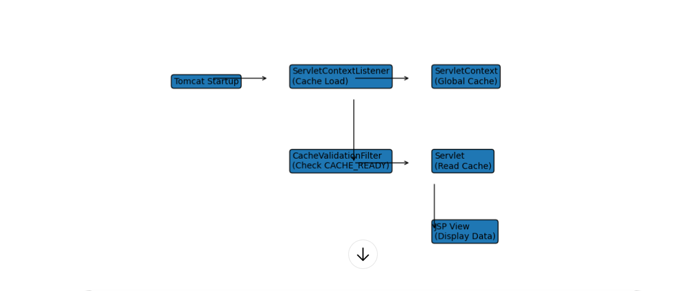

🧠 READ THIS DIAGRAM (STEP-BY-STEP)
1️⃣ Tomcat Startup
- Application is deployed
- No requests are allowed yet
⬇️
2️⃣ ServletContextListener (Cache Load)
- contextInitialized() is called once
- Reference/master data is loaded
- Cache is validated
- Stored in ServletContext
⬇️
3️⃣ ServletContext (Global Cache)
- Acts as application-wide shared memory
- Cache is immutable and thread-safe
- Accessible by all servlets & JSPs
⬇️
4️⃣ CacheValidationFilter
- Executes before every request
- Checks CACHE_READY
- Blocks requests if cache is unavailable
⬇️
5️⃣ Servlet (Read Cache)
- Reads cache from ServletContext
- Business logic uses cached data
- Forwards data to JSP
⬇️
6️⃣ JSP View
- Uses EL & JSTL
- Displays cached data

🔥 WHY THIS DESIGN IS IMPORTANT
Concept | Why it matters
Listener | Startup lifecycle hook
Filter | Request gatekeeper
ServletContext | Global cache store
Immutable cache | Thread safety
Fail-fast | Prevents partial state

“Cache is eagerly loaded at startup using a ServletContextListener, validated before serving traffic via a filter, stored in ServletContext, and consumed by servlets and JSPs in a thread-safe manner.”

